INTRODUCTION
This report is an individual extended group project for Case Study B, the E-commerce Order Fulfilment & Inventory Optimization System. In this project I expand and extended the backend by turning it into API gateway that contains three external Web APIs, adding shipment tracking and also add new features with new database tables and transactional request, strengthen it with input validation, SQL injection prevention and password hashing and put it under Git control and deploy it to cloud.
Node.js, Express.js, and MySQL are cloud hosts. The front-end files in the public folder are taken and unchanged from group project.
Summary of Extensions
Area | Contribution
Task 1 Web APIs | - ExchangeRate-API currency convertor  - Zippopotam.us checks postcode validity  - Telegram Bot API order notifications
Task 2 Database | - New tables Shipments and order status history  - Row locked transactions for orders, status changes and shipments  - Full CRUD for products, orders and shipments
Task 3 Security | - Bcrypt hashing, express validator, controlled queries, rate limiting, role check, JWT in httponly
Task 4 Deployment | - Git, .env/.env.example/.gitignore, GitHub, Railway with managed MySQL.

APPLICATION DEVELOPMENT
Task 1: Web API Architecture & Implementation
Architecture
The Express server functions as middleware between browser clients and services of third party. Clients cannot communicate with external providers directly. They call endpoints, weigh the validity of the request, call the provider with a timeout, and respond or return a normalized JSON shape. This keeps API keys on the server, cache responses and divides the front-end from provider changes. All the integration is kept in src/externalApis.js and directed in server.js.

System Architecture: E-commerce Order Fulfillment API Gateway
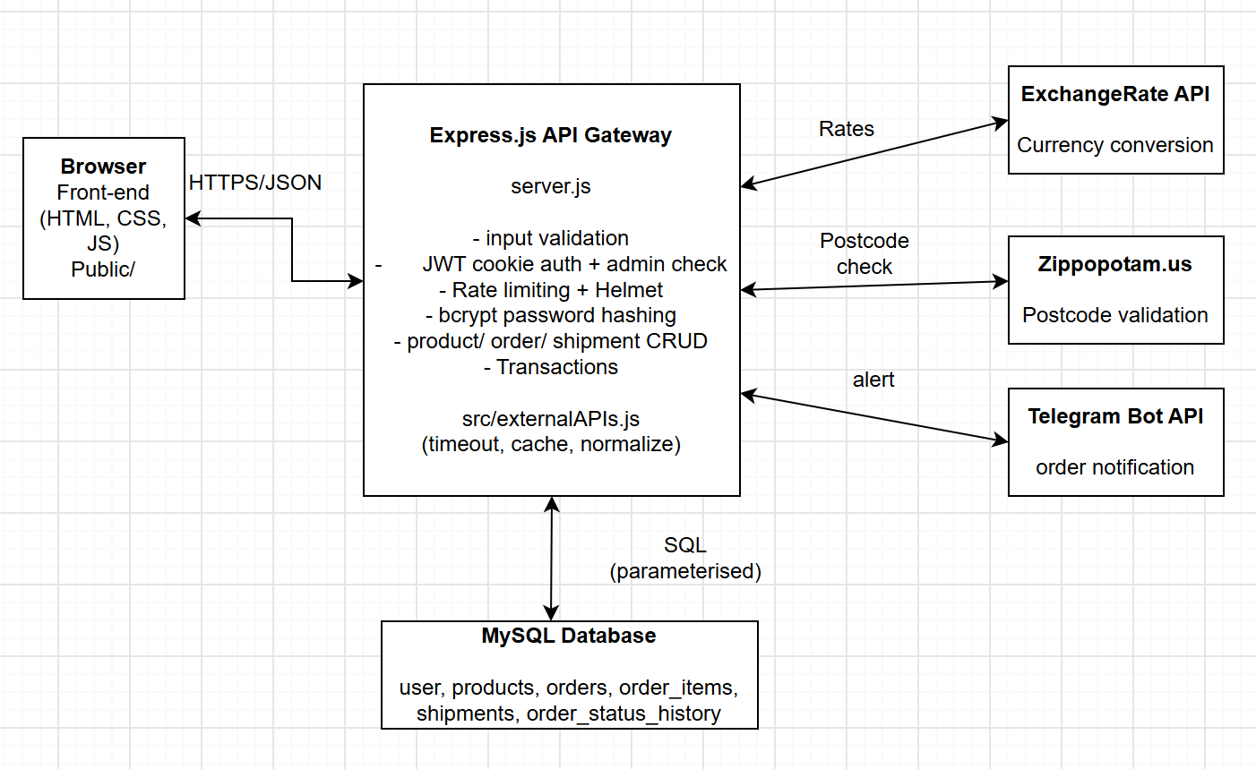
Implementation
Every outbound request uses fetch with AbortSignal.timeout(5000). Given failures are converted and exported to ExternalApiError with HTTP 502, so clients are able to identify errors from upstream failures.
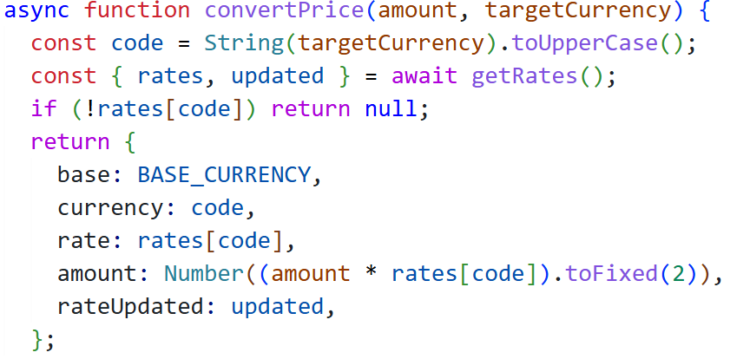

Currency conversion API response
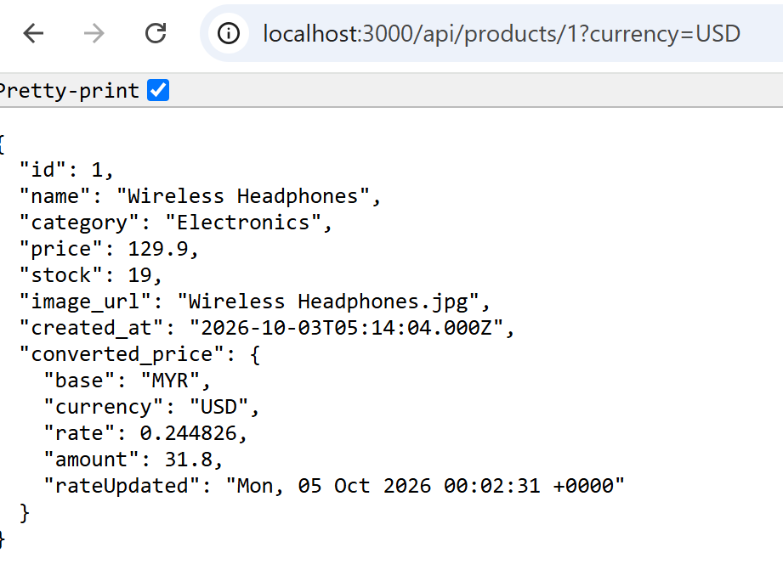
Postcode validation API: True/valid
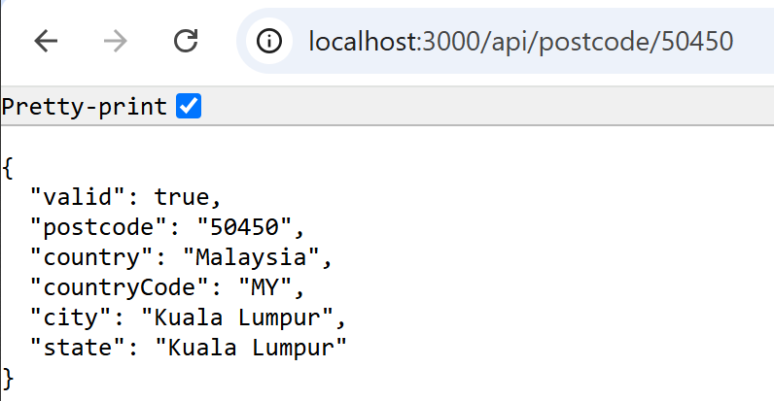

False/invalid
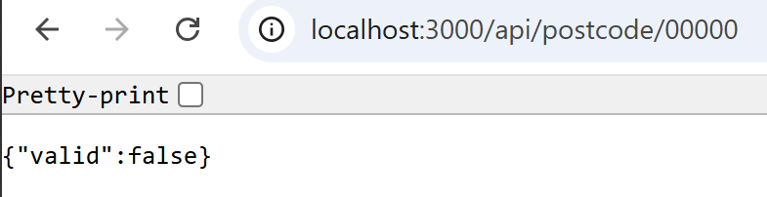
Core API Endpoint Summary
Method | Route | Auth | Purpose
POST | /api/login, /api/logout | Public | Authenticate/ end session
GET | /api/products, /api/products/:id | Public | Catalogue- optional on currency conversion
POST, PUT, DELETE | /api/products[/:id] | Admin | Product CRUD
POST | /api/orders | Public | Manage to place order, to do transaction, postcode check and notification.
GET | /api/orders, /api/orders/:id | Admin | List orders or details of the order, shipment and history
PATCH, DELETE | /api/orders/:id/status/, /api/orders/:id | Admin | Able to change status or audit and delete
GET, POST, PUT, DELETE | /api/shipment[/:id] | Admin | Shipment CRUD
GET | /api/track/:trackingNo | Public | Customer manage to track lookup

TASK 2: EXPRESS.JS DATABASE INTEGRATION & FEATURE EXTENSION
New feature: Shipment Tracking and Order Audit Trail
The old or group project could allow customers to place and delete orders, but it had no fulfillment stage. The new feature records a shipment, for example courier, tracking number, and validated address for every order. The new system keeps the shipment status in sync together with the order status, logs of every status change in the audit table. The cancellation of the order automatically returns quantities to stock, in support of inventory optimization.
Schema Design
Tables in ecommerce_db
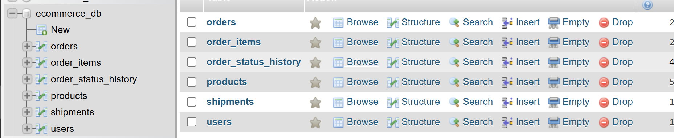
Entity relationship Diagram
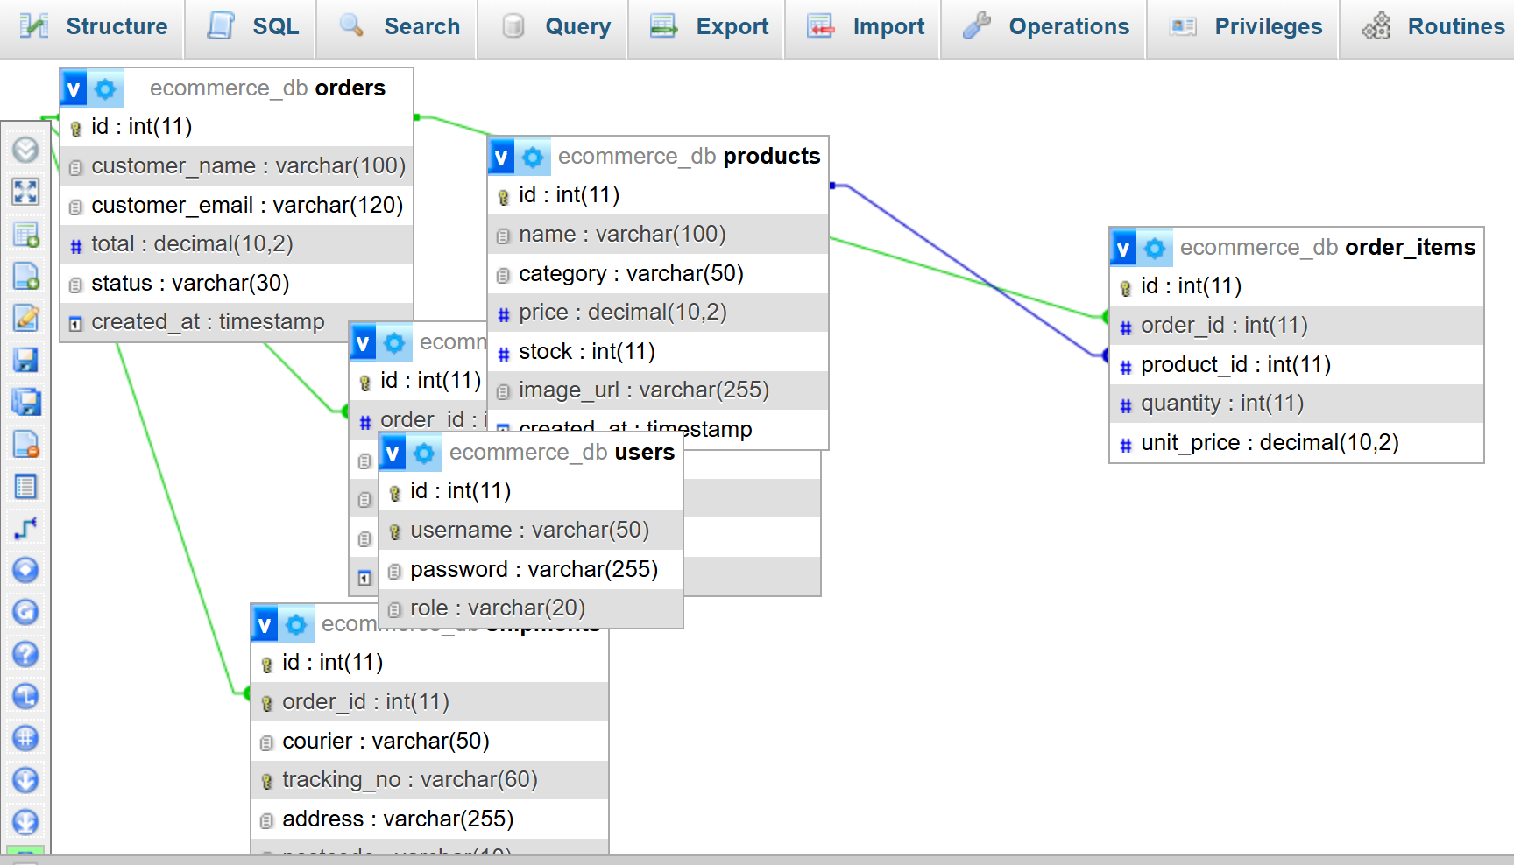
Transactional Queries
Three of the operations correct and modify several tables and are covered in transactions so that the database is always updated.
Place order
Insert the order, items, decrement stock, write down the first history row and manage to create shipment. Product rows are read with SELECT…...FOR UPDATE this avoids two or more customers to buy the last unit. Any error cause ROLLBACK.
Change order status
This locks the order row, refuses invalid transactions, restocks items on cancelation, updates the order, syncs the shipment and also inserts the history row all in one commit
Create shipment
Locks the order, validates if the order is not cancelled or delivered, moves the pending order to processing
Order Placement Response
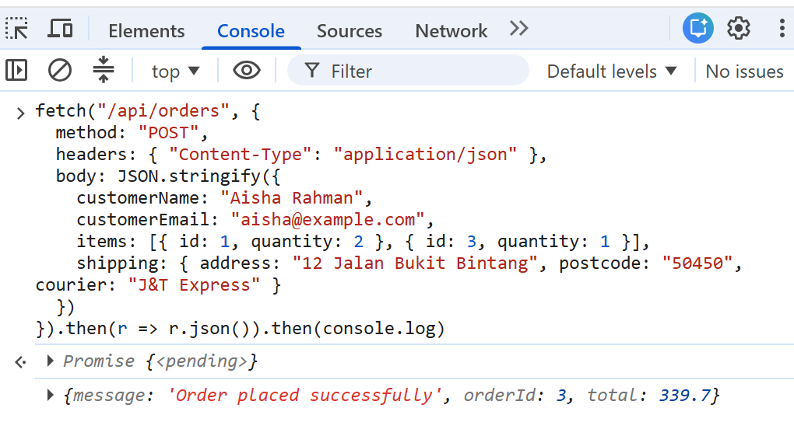

Order detail with items, shipment and audit history
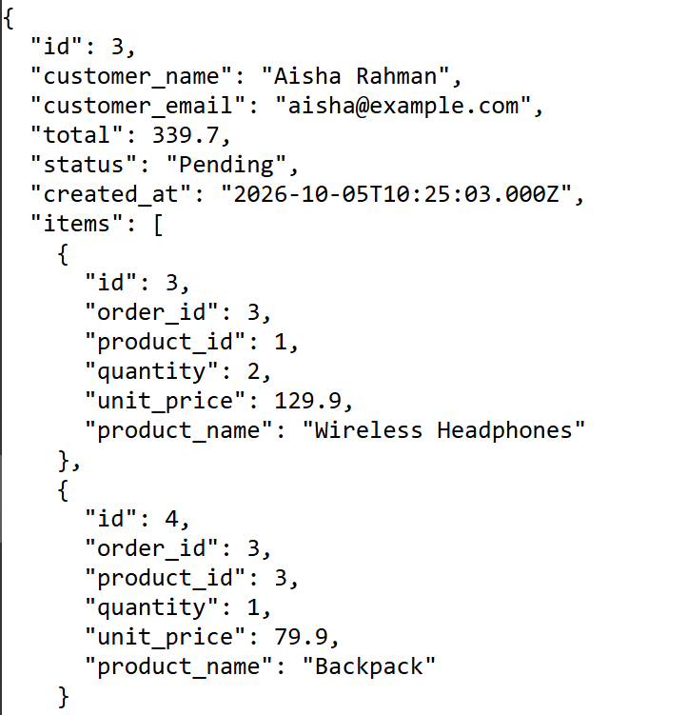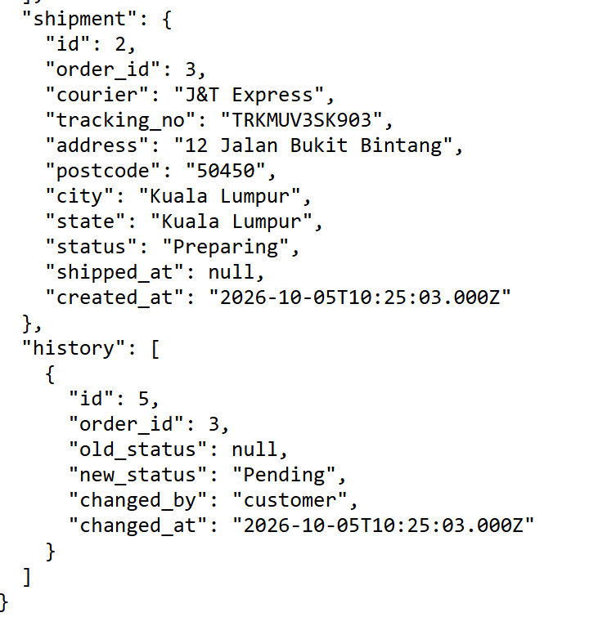
New tables populated after an order
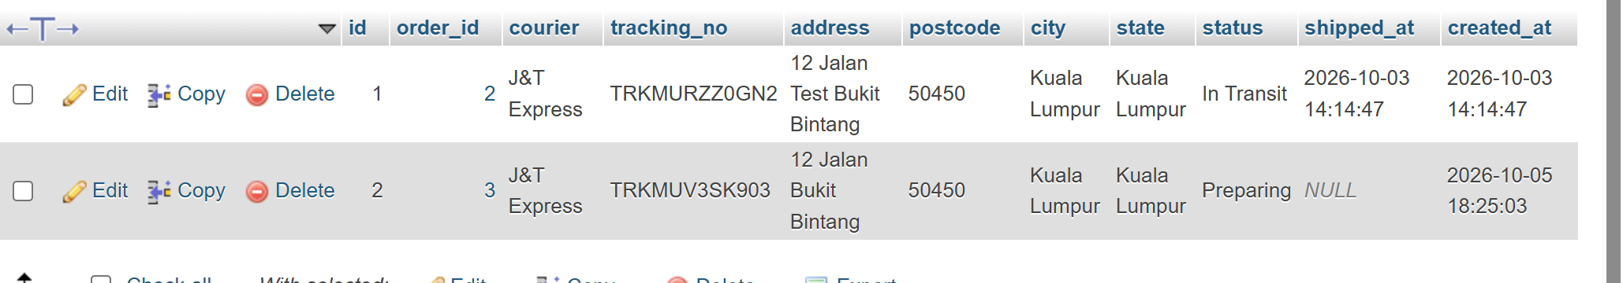
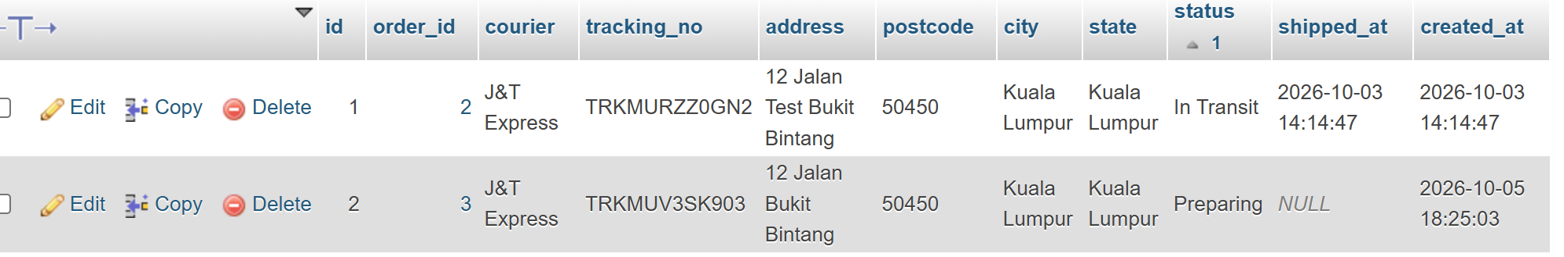
Stock decrement and restock
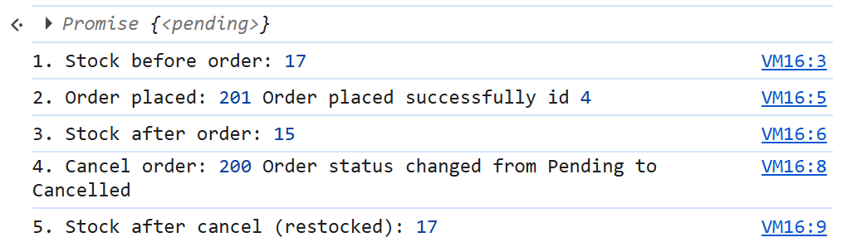
Transaction rejection of excessive quantity
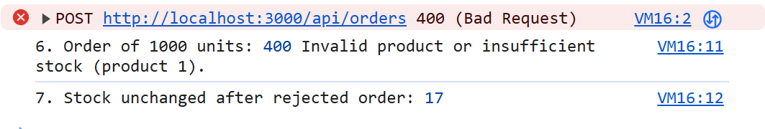

TASK 3: WEB APPLICATION SECURITY IMPLEMENTATION
Input Validation
Each route that accepts data is declared as an express validator chain and a shared validate middleware that returns HTTP 400 with per field messages. The validation includes type and range, for example price greater or equal to stock integer, quantity 1 to 1000, the length limits match with column number, email format, allow the list of status values, and also a strict postcode pattern. The strings fields are cut short and HTML to shorten stored cross site scripting.
SQL Injection Prevention
All provided statements use MySQL2 placeholders (?), the values are sent separately from the SQL text. The array form is used for items listing. Validation put a second layer by malformed ids before they reach the database. On login it selects by username only and compare the password provided in code
SQL injection attempt rejected
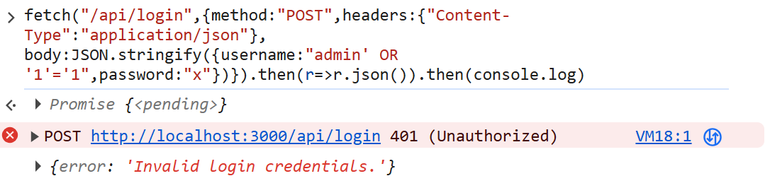

Password Hashing
The group version stored and compared plaintext passwords- admin123. The passwords are hashed with bcrypt. The admin account is created by installing or run npm run seed:admin, which can read credentials from .env and manages to store only the hash. Login uses the bcrypt.compare and runs a comparison against dummy hash when the username does not exsist, so sometimes the response can not show valid usernames.
Bcrypt hashed password in the users table
Authentication, Authorization & Additional Protections
A signed JWT 2 hours expiry stored only in an httpOnly, samesite cookie so that javascript can not be able to read it, Authorization requireAdmin middleware protects writes -all order and shipment management routes. In previous group project these were open to anyone. Brute force – limited logins only 10 attempts per 15 minutes per IP, other API routes limited to 300 per 15 minutes. Error handling – in production, internal error details are placed by a generic message and logged server side.
Automated test results for Task 1 to 3
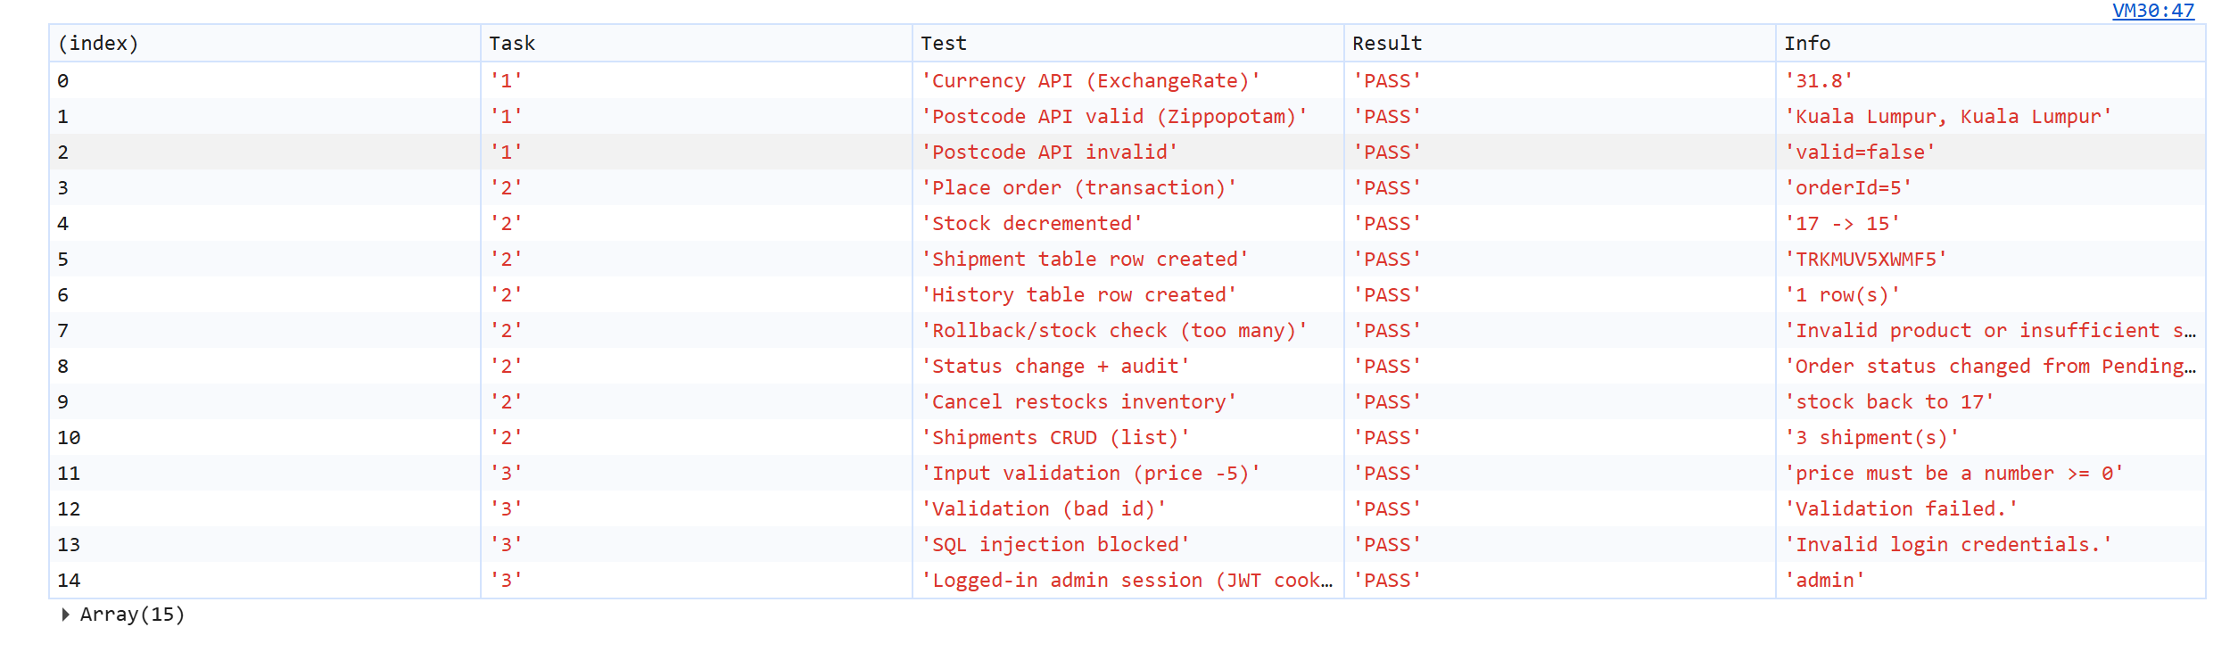

Admin routes blocked without login
